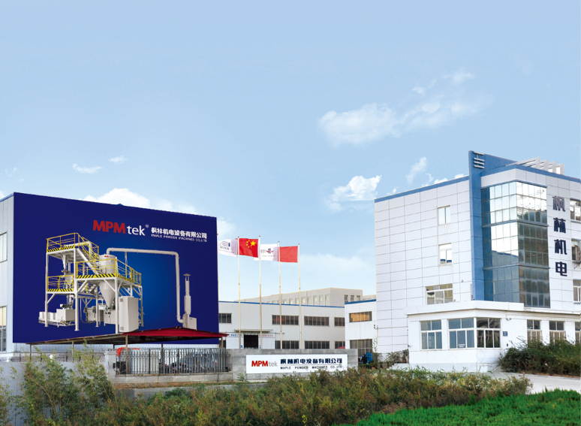
MAPLE MACHINE (MPM tek) was established in 2006. Since 2009, MPM tek commences to R&D and manufacture the POWDER COATING TECHNICAL EQUIPMENT (machines and production lines) professionally.

MPM tek owns a high-level engineering team who masters advanced technology and design theory of PRE-MIXER, EXTRUDER, ACM GRINDING SYSTEM, POST-MIXER, and POWDER COATING PROCESSING LINE.

The Product of MPM tek wins the praises from not only powder coating manufacturers but also processing equipment manufacturers for the reasons of QUALITY, RELIABILITY and PERFORMANCE PRICE RATE.

The Design and Construction of Product of MPM tek, such as MIXER, EXTRUDER, COOLING BAND and ACM MICRO-GRINDING SYSTEM, are in conformity with European Directives (LOW VOLTAGE 2006/95/EC and MACHINES 2006/42/EC), and have been obtained CE MARK.

MPM tek provides the PRESSURE SHOCK RESISTANT TO 11 bar (PSR11) ACM MICRO-GRINDING SYSTEM designed and manufactured according to the STANDARDS ON 《PRESSURE SHOCK RESISTANT VESSELS AND APPARATUES》 AND《PRESSURE VENTING OF DUST EXPLOSION》of both GB and EN.

Safety, Automation, Cost Saving , Environment Protection and perfect After-Sales Service are our tenets for the R&D, manufacturing and sales of powder coating processing equipment, also the promise to our customers.

